1. Check Whether a Number is Positive, Negative, or Zero (IF-ELSE)
DECLARE
num NUMBER := -10;
BEGIN
IF num > 0 THEN
DBMS_OUTPUT.PUT_LINE('Positive Number');
ELSIF num < 0 THEN
DBMS_OUTPUT.PUT_LINE('Negative Number');
ELSE
DBMS_OUTPUT.PUT_LINE('Zero');
END IF;
END;
/
OUTPUT:

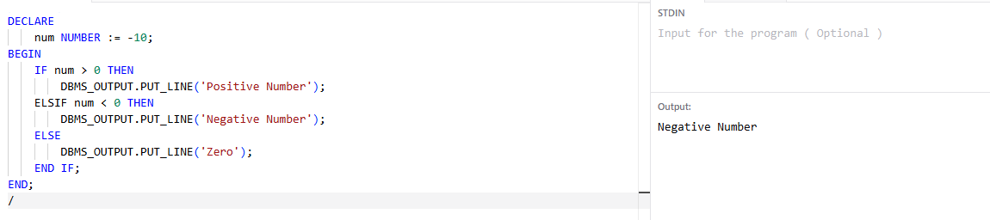

2. Find the Largest of Three Numbers
DECLARE
a NUMBER := 20;
b NUMBER := 45;
c NUMBER := 35;
BEGIN
IF a > b AND a > c THEN
DBMS_OUTPUT.PUT_LINE('Largest = ' || a);
ELSIF b > c THEN
DBMS_OUTPUT.PUT_LINE('Largest = ' || b);
ELSE
DBMS_OUTPUT.PUT_LINE('Largest = ' || c);
END IF;
END;
/
OUTPUT:

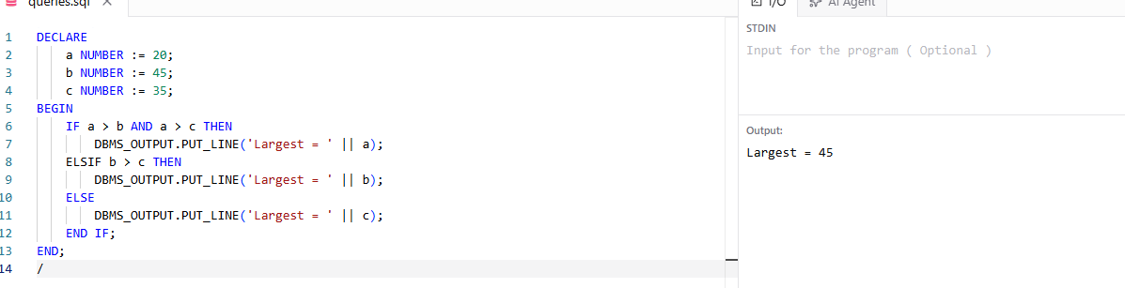

3. Grade Calculation Using CASE

DECLARE
marks NUMBER := 85;
BEGIN
CASE
WHEN marks >= 90 THEN
DBMS_OUTPUT.PUT_LINE('Grade A');
WHEN marks >= 75 THEN
DBMS_OUTPUT.PUT_LINE('Grade B');
WHEN marks >= 50 THEN
DBMS_OUTPUT.PUT_LINE('Grade C');
ELSE
DBMS_OUTPUT.PUT_LINE('Fail');
END CASE;
END;
/
OUTPUT:
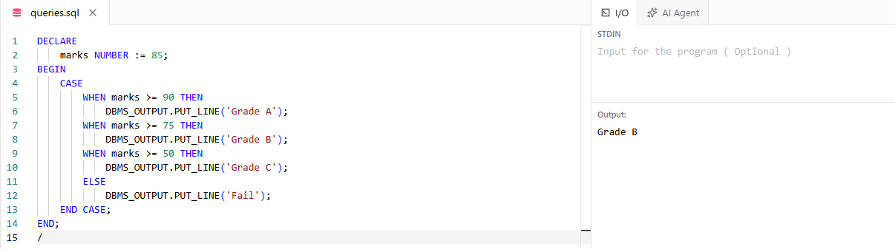

4. Reverse a Number
DECLARE
num NUMBER := 12345;
rev NUMBER := 0;
rem NUMBER;
BEGIN
WHILE num > 0 LOOP
rem := MOD(num,10);
rev := rev*10 + rem;
num := TRUNC(num/10);
END LOOP;

DBMS_OUTPUT.PUT_LINE('Reverse = ' || rev);
END;
/
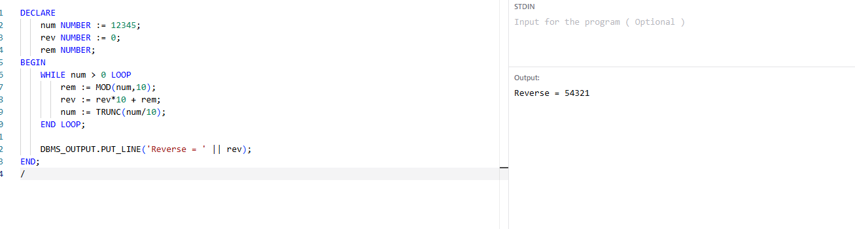
OUTPUT:

